MiraSeed › Bible
User Guide
Read Scripture closely. Study it with care.
English · Web edition
Open in your browser
bible.miraseed.app
For: Pastors · Small groups · Personal study · Seekers
On the App Store, listed as “MiraSeed Bible Study.”
Version 1.0.1 · 2026

MiraSeed · Bible

What is MiraSeed Bible?
MiraSeed Bible is an AI-assisted study companion that brings structure to careful Bible reading — in your language. Tap a verse for clear, sectioned commentary, ask plain-language follow-ups, read two translations side by side, and keep your notes in one place.
- Structured commentary, not a wall of text — drawn from four classical traditions.
- Bilingual reading: two translations of the same verse, side by side.
- Your notes, synced across iPhone, Android, and the web.
- A concordance search across Scripture, connected to the rest of your study.

Where it runs
iOS, Android, and the web, in approved markets. The interface is available in six languages. This guide covers the web edition.

A study assistant, not an AI pastor — the final word is never the AI’s.

Contents
Update this field in Word (right-click → Update Field) to build the contents.

Step 1

Open the Web App
Go to bible.miraseed.app, or open miraseed.app and choose MiraSeed Bible → Web. The web app launches in your browser — nothing to install. (On a phone, download from the App Store or Google Play.)
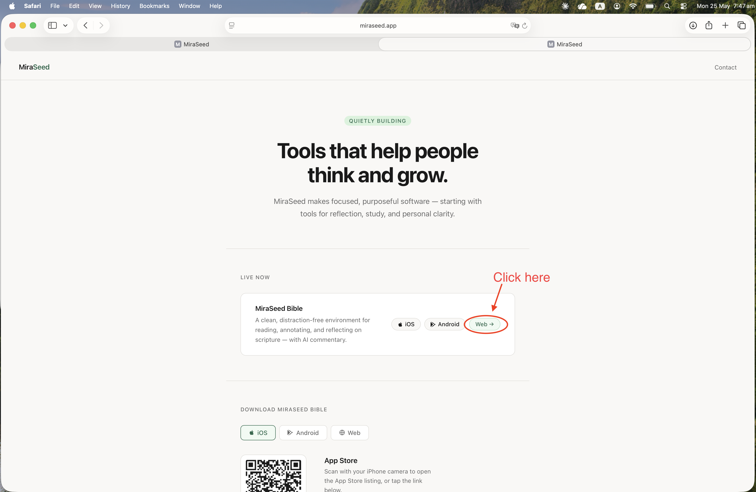
The MiraSeed home page — choose the Web button to launch.

Step 2

Select a Verse
Open any chapter. Verses appear in two languages side by side — for example English (KJV) and 和合本. Press and hold a verse, such as Romans 8:28, to bring up the verse menu.
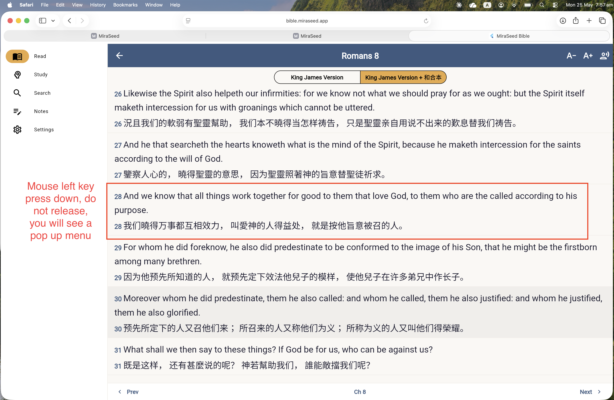
Romans 8 in bilingual view — press and hold a verse to select it.

Step 3

Open AI Commentary
From the verse menu — Add Note, View Commentary, Listen from Here, Copy Verse — choose View Commentary. MiraSeed Bible generates a structured commentary for that verse. (AI commentary needs an internet connection.)
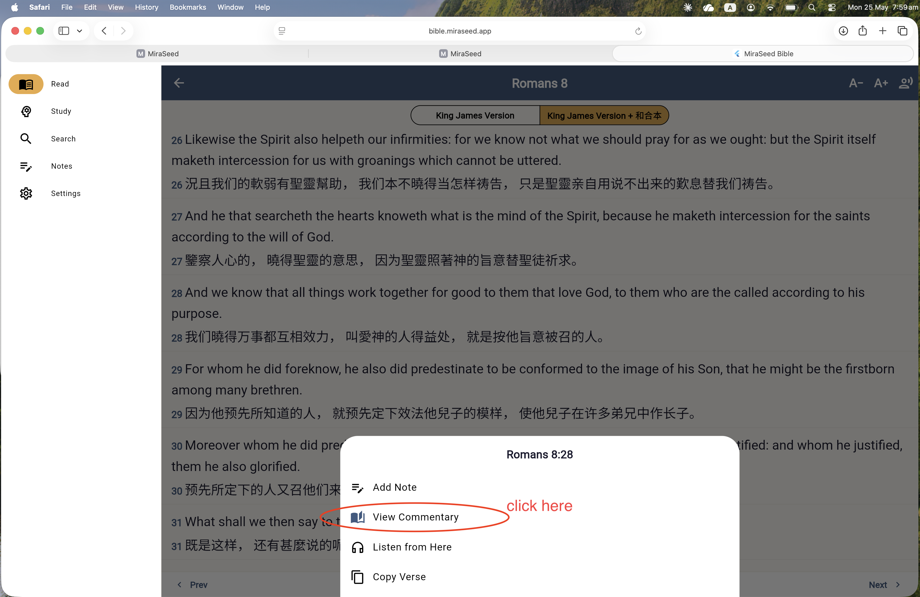
The verse menu — choose View Commentary.

Step 4

Ask Follow-up Questions
After reading the commentary, type a follow-up in the box at the bottom — for example, “How can all things work together for good?” — and send. You can ask up to three follow-ups per verse.
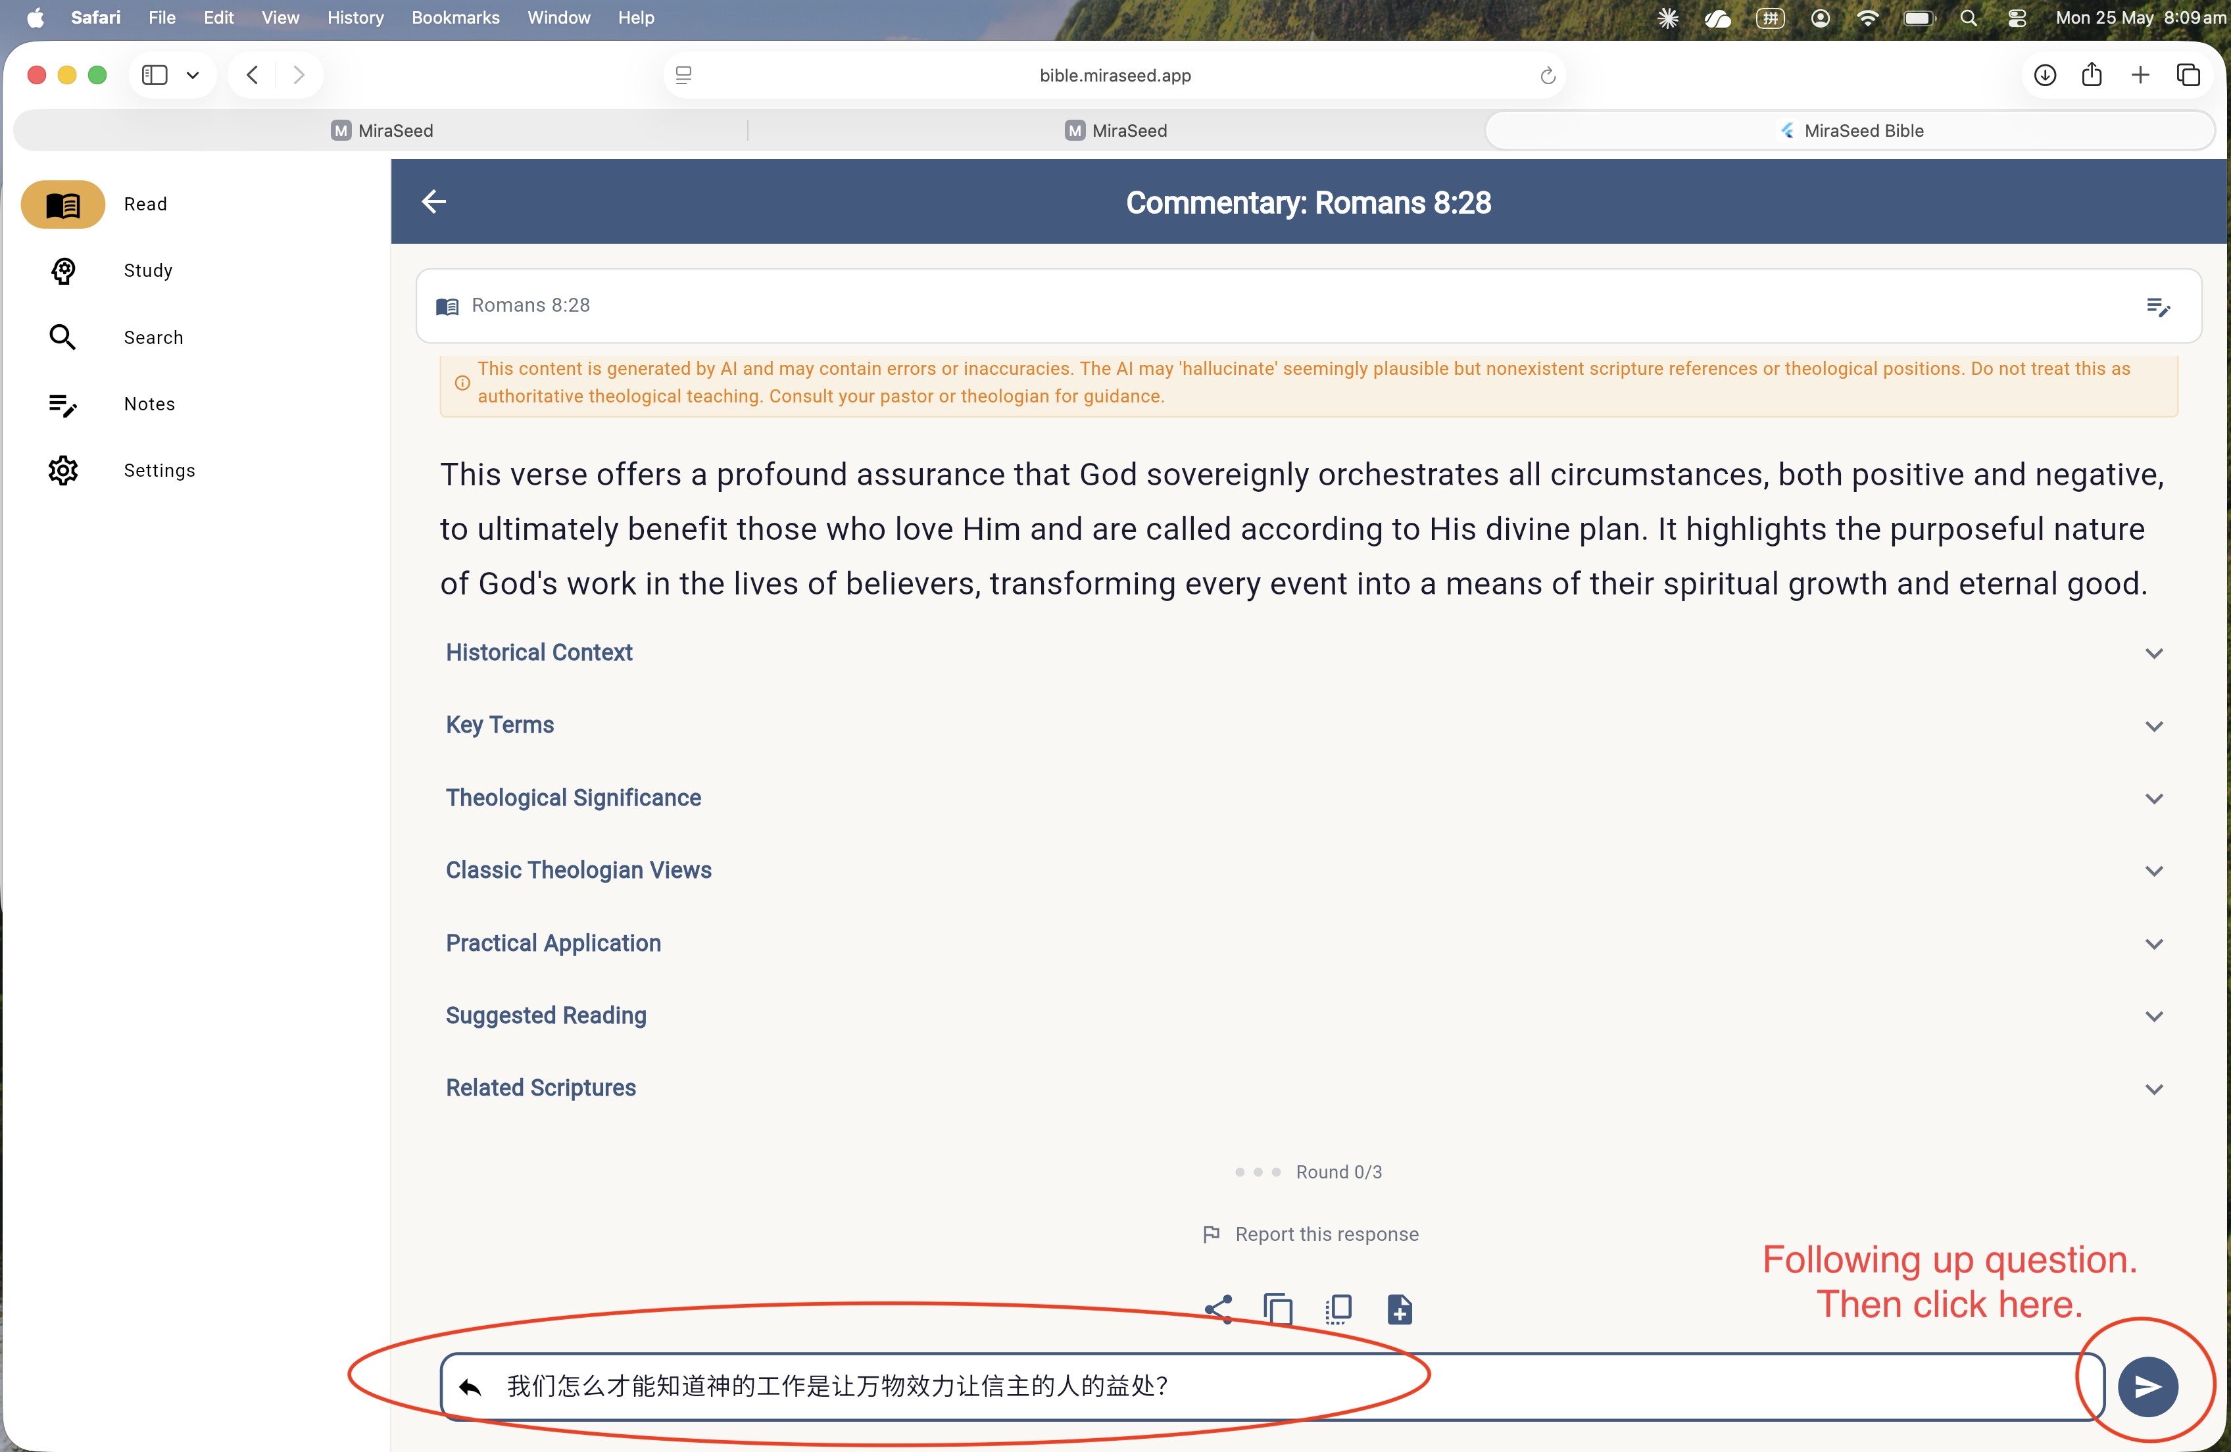
The AI commentary view, with the follow-up box at the bottom.
Tip — reply in any language
Ask in plain language, and switch the reply’s language any time: “Can you explain it in English?” / “请用中文回答。”

Step 5

Save to Notes
When you see “Follow-ups complete ✓,” the full study — commentary, key terms, traditions, and your follow-up Q&A — is ready. Tap the + button to save it to your notes.
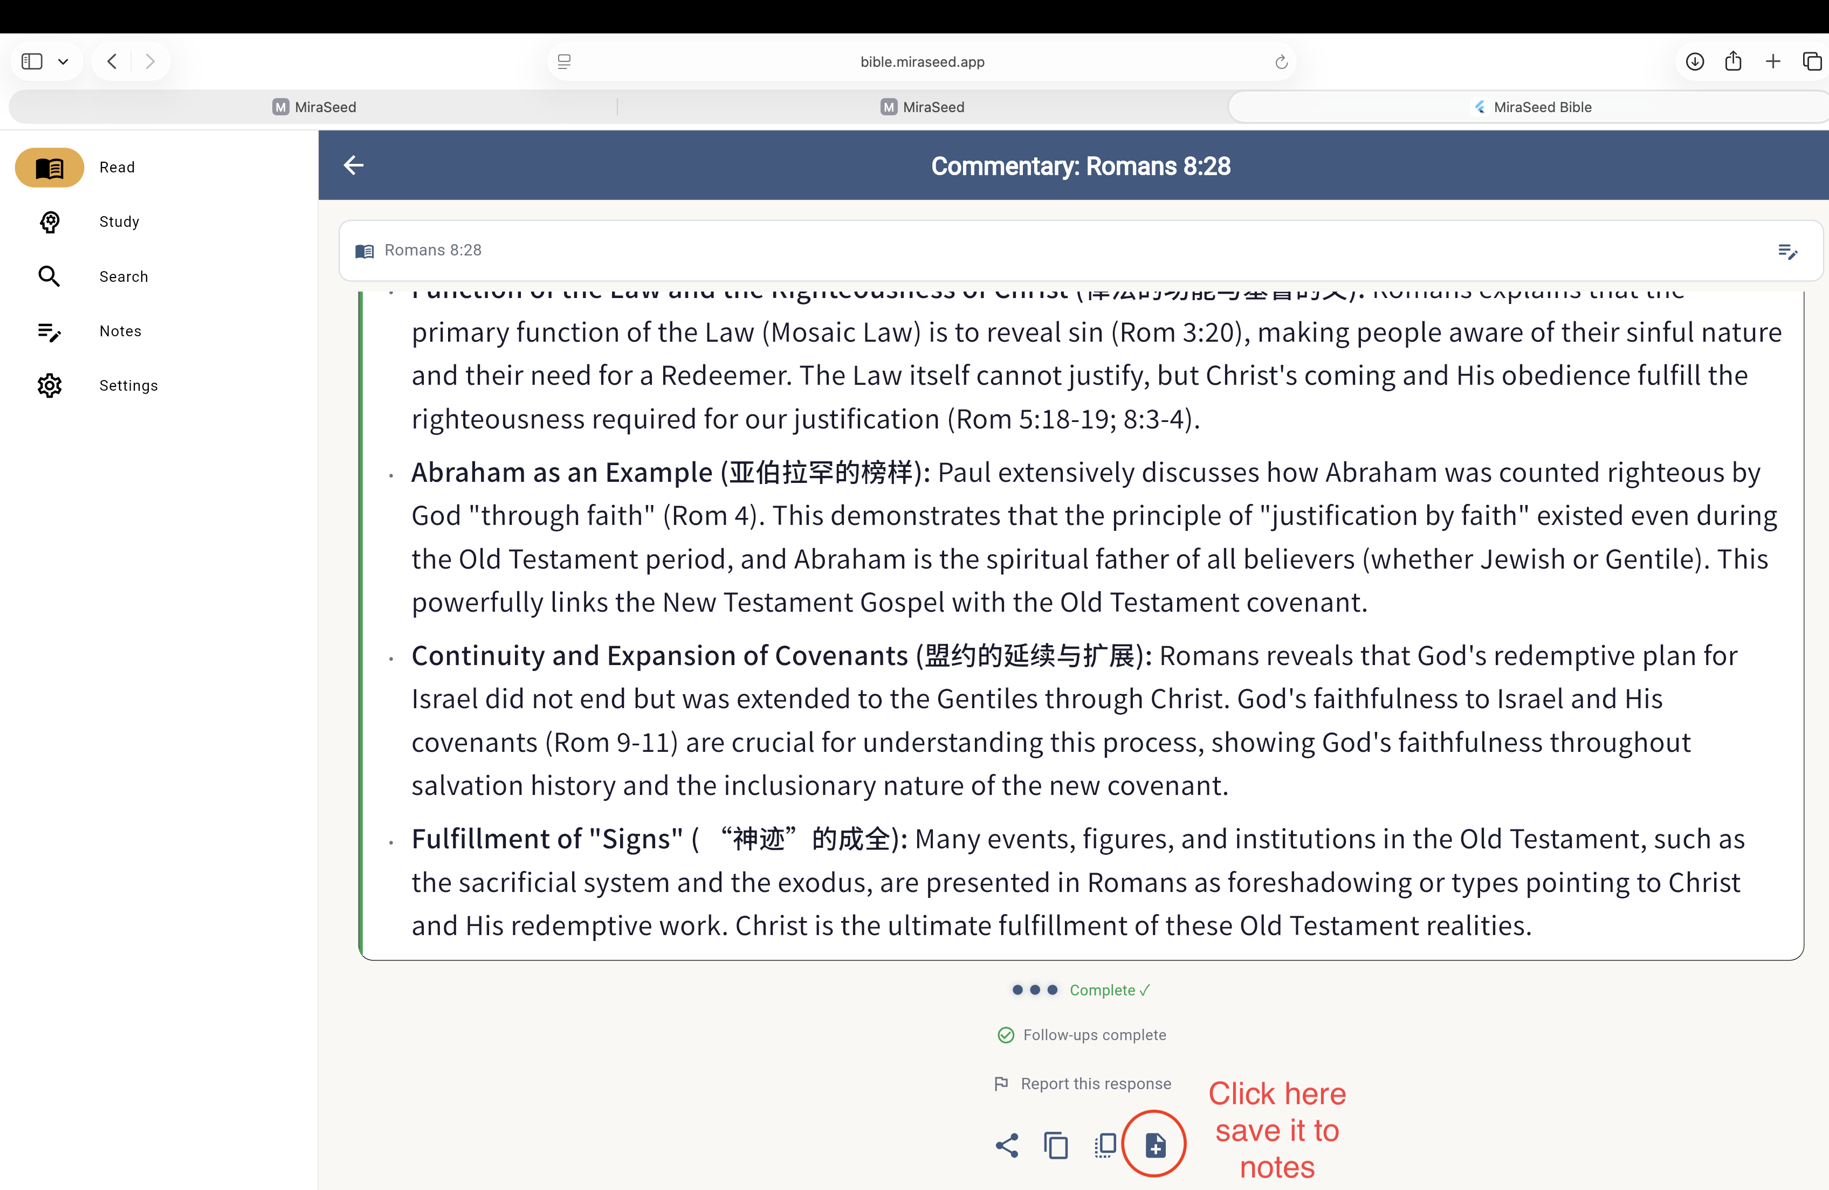
Follow-ups complete — tap + to save the study to your notes.

Step 6

Open Your Notes
Open the Notes tab. Your saved study appears at the top, organized by verse and date. Notes sync across your devices automatically.
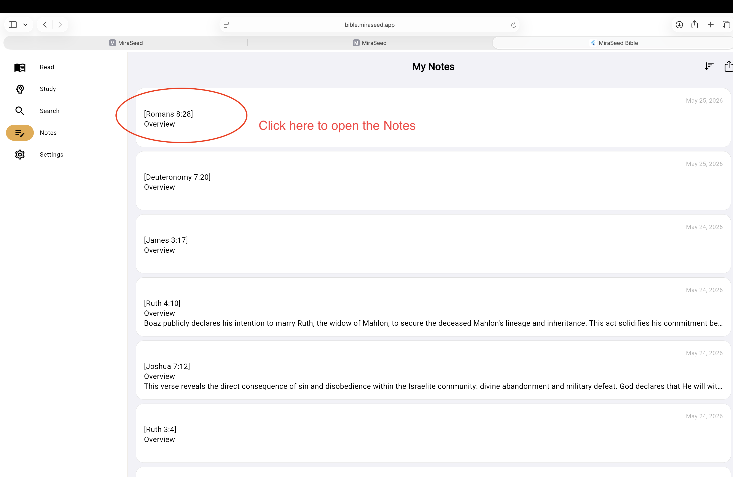
My Notes — saved studies, newest first.

Step 7

Review a Note
Open a note to see the full study: overview, historical context, key terms, theological significance, classic views, application, suggested reading, related Scriptures, and your follow-up Q&A. To share it, tap the Share/Export icon.
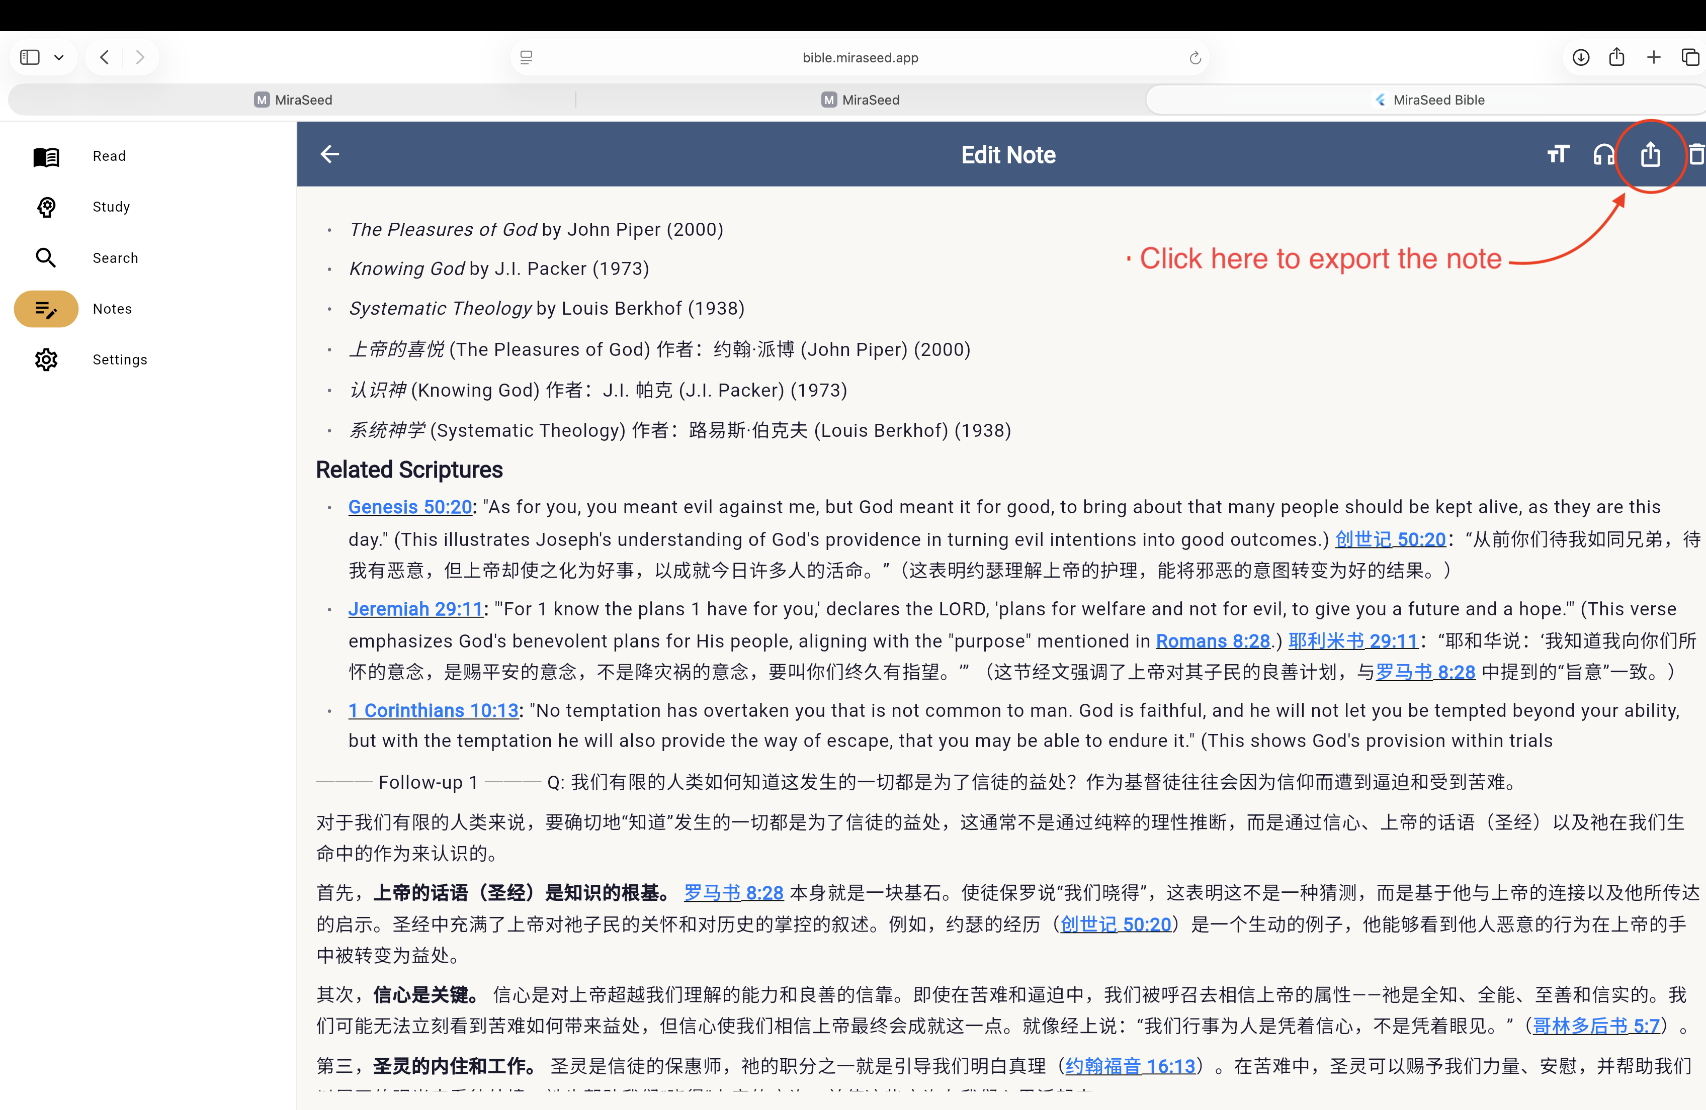
A saved note opened for review — Share/Export is at the top right.

Step 8

Export as PDF or Word
Choose a format — Plain Text (.txt) for email, PDF (.pdf) for printing or teaching, or Word/RTF (.rtf) for editing. The file downloads to your computer, ready to print, share, or hand out.
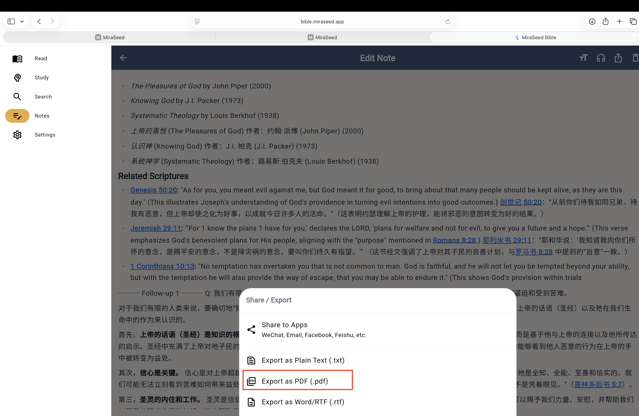
Export options — choose PDF for print, or Word/RTF to edit.
Made to print and edit
Exports open cleanly in Pages and Word, so a leader can print the study or adapt it for a class.

Step 9

Concordance — Search & Jump
Open Search — the Concordance. Type a word or theme, say faith, and MiraSeed Bible lists every occurrence across Scripture with the word highlighted (for example, “faith” — 338 occurrences). Tap any result to jump straight to that passage, where you can open AI commentary or save it to your notes — then return to your search with one tap.
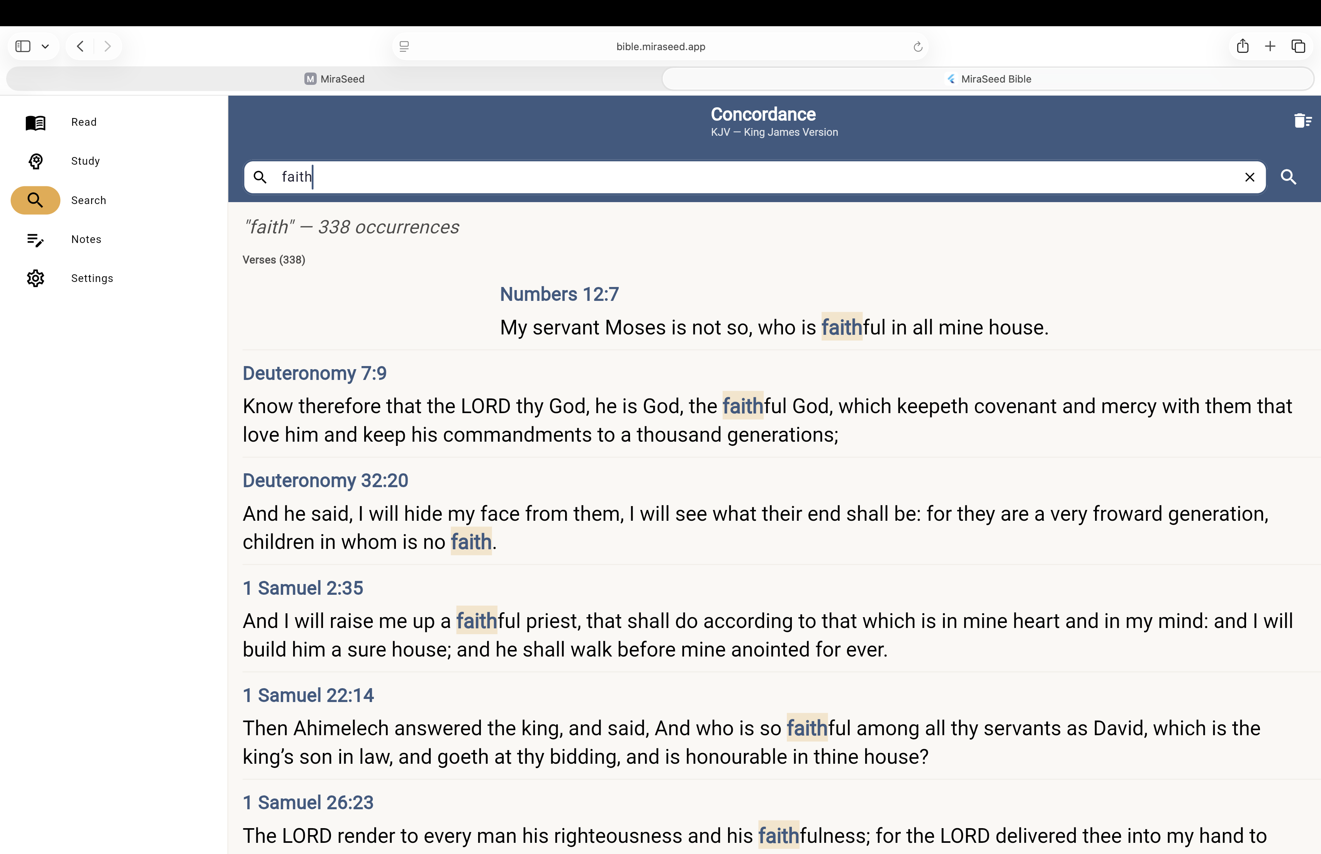
Concordance search for “faith” — every occurrence, ready to jump to.
Search that stays connected
From any result you can jump to the passage, open AI commentary, or save to notes — and easily come back to keep searching.

MiraSeed · Bible

Feature map
How the things you saw on the home page map to the app — and where to find each one in this guide.
FEATURE | IN THE APP | GUIDE
AI commentary | Verse menu → View Commentary | Step 3
Follow-up questions | Box below the commentary (up to 3) | Step 4
Structured commentary | Sectioned study · four classical traditions | Step 7
Bilingual reading | Two translations, side by side | Step 2
Concordance / Search | Search tab → type a word → tap to jump | Step 9
Photo input (Scan) | Mobile: camera · Web: upload an image | See note
Notes, synced | Notes tab, across your devices | Steps 5–6
Export (PDF / Word) | Share/Export on any note | Step 8
Photo input (Scan) extracts text from a printed Bible page, your own notes, or a church brochure. On a phone, use the camera; on the web, upload an image you’ve saved.

MiraSeed · Bible

Boundaries & honesty
MiraSeed Bible is a study assistant, not an AI pastor. It does not replace churches, pastors, sermons, theological training, or your own discernment. The final word is never the AI’s.
The web edition needs the internet
This guide covers the web edition, which runs in your browser — so it needs an internet connection to open and to work. Online, you can:
— Read the Bible text and your notes
— Search the Concordance across Scripture
— Open AI commentary and ask follow-up questions
— Use Photo input (Scan) — choose a photo from your library
— Sync your notes across your devices

Want to study offline?
Print this guide, or use the MiraSeed Bible app on iPhone or Android. The printed guide always works — no connection needed — which is exactly why it’s here.

A few honest notes
- There is no “daily verse” feature — MiraSeed Bible is for study you begin, not a feed.
- AI can be wrong or incomplete; read it as a study aid and weigh it against Scripture and your community.
- Photo accuracy varies with image quality; check the extracted text before relying on it.

MiraSeed · Bible

Quick-start card
Tear off and keep — a one-page path through a study.
- Open bible.miraseed.app in your browser.
- Find a verse — or Search a word in the Concordance and tap a result.
- Press and hold the verse → View Commentary.
- Read the structured study; ask up to three follow-ups.
- Tap + to save it to your notes.
- Open the note → Share/Export → PDF or Word.
- Print it, hand it out, or edit it for your group.

Good to know
— Reply in any language — just ask.
— Notes sync across iPhone, Android, and web.
— AI features need internet; reading the text and your notes do not.
— A study assistant — not a replacement for your pastor or your discernment.
For small groups: print this card for everyone, or export a study and hand it out.

Thank you for studying with MiraSeed Bible.
Contact: support@miraseed.app · hello@miraseed.app
Links: miraseed.app · bible.miraseed.app
On the App Store, listed as “MiraSeed Bible Study.”
Version 1.0.1 · 2026
© 2026 MiraSeed. MiraSeed is a family of purposeful tools.

